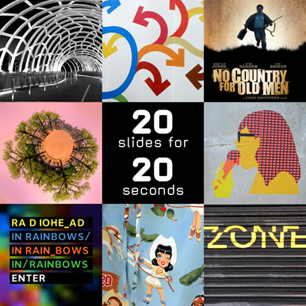
Pecha Kucha (“Chit Chat”) :
Modified:
20 X 20 Speech Performance
For your Pecha Kucha speech performance, I invite you to select a topic that interests you, will interest others, and that you have some prior knowledge of either from personal experience or prior research.

Have fun with this project—pick a topic that excites you, something you love, or something you feel passionate about!

Research:
No matter what topic you choose, you will need to do some background research and have at least 3 sources to support various aspects of your presentation. These sources will be typed in MLA format on a Works Cited page to be turned in when you give your presentation. As you perform your Pecha Kucha speech, be sure to acknowledge any sources used for statistics, ideas, or background information.

Slides:
Also for this project, you will create a presentation of twenty slides that automatically progress at 20 seconds per slide (hence, “20x20”) to support your oral performance, a total of 6 minutes and 40 seconds. Your slides will provide the audience with visual and textual cues that enhance your message. Slides should bring clarity and relevance to your presentation. Some slides might provide the audience with a moment of ambiguity or tension, which you clarify while the slide is displayed. Remember to use restraint and simplicity (Presentation Zen moves) as you design your slides.

Your final packet will include:
- Script or outline for your presentation
- Works Cited
- Illustrations (Slide with the name and web address for each graphic/picture)
- Printout of your slides (Handouts: 3 per page)

Presentation:
The Pecha Kucha presentation should be delivered in a natural and conversational way. The 20 second limit encourages you to be concise and efficient with the words you speak. So develop a script outline and practice, practice, practice. Your P-K presentation & outline should have the following components:

Theme: A phrase that concisely states what you will be talking about (it can be a catchy phrase).

Strong Opening: Capture your audience’s attention (use a story or a startling quote or statistic). Place your opening in the context of your presentation theme. Make it easy for your audience to understand where you are going.

Connect to your audience: Tell the audience why they should care about your topic/theme.

Body:
Outline the 3 or 4 items you are going to talk about.
Provide a transition between each of your major items.
Make any numbers you use meaningful (refer to the source of your info).
Keep your message simple.
Use props if appropriate.

Strong Conclusion:
Briefly summarize your main point(s).
Remind the audience why you care about your topic—
and why they should care, too.
Close by connecting back to your opening story, quote, or statistic.

Enthusiasm: Demonstrate enthusiasm and excitement about your topic throughout your presentation. Speak in a conversational tone—be natural—remember this is fun!!!!!

_______________________________________________________
According to Pecha-Kucha.org: Good PechaKucha presentations are the ones that uncover the unexpected, [such as] unexpected talent [or] unexpected ideas. Some PechaKuchas tell great stories about a project or a trip. Some are incredibly personal, some are incredibly funny, but all are very different making each PechaKucha Night like 'a box of chocolates'.

Take this opportunity to tap into your creative talents while exploring the various textual and visual rhetorical elements that best support the message you wish to convey to the audience. Use the sites below as examples of how to develop your presentation.

Present like Steve Jobs: http://www.youtube.com/watch?v=2-ntLGOyHw4
Pecha Kucha Dallas Fort Worth: http://www.youtube.com/watch?v=F5No4SvDnQs
[Great Example and Background Info]
Pecha Kucha 20x20 http://www.pecha-kucha.org/what
End to Boring PowerPoints: http://www.youtube.com/watch?v=Fils7clg6iU&feature=related
Background on Pecha Kucha: http://www.youtube.com/watch?v=zaXjiKcD4os&feature=related

Image: http://www.playgroup.com/blogs/images/useruploaded/steve/steve_1.jpg

