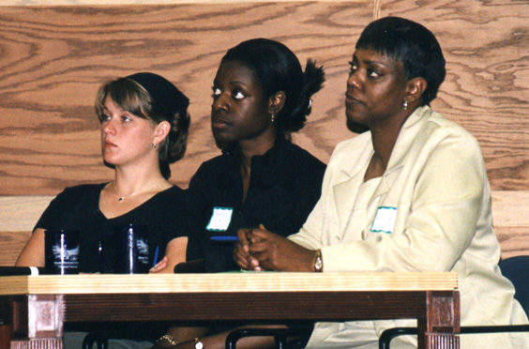
http://www.strom.clemson.edu/presentations/women/StudentPanel.jpg
Use Chapter 6: Informative Speaking
Project #3 – PANEL PRESENTATION
Panel presentations occur throughout the academic, political, and business communities on a daily basis. These kinds of presentations can be formal or informal and occur at professional conferences, organized meetings, community town halls, and board meetings (to name a few).
For this project, you will select two to three partners to be part of your panel. Together, you will select a current public issue to research. Preferably, these topics will fall under one of the research domains listed on our website. Each member of your panel will select a unique issue and then present (3 minutes) to the class as part of a complete formal panel presentation. The basic thrust of this presentation is Information and Analysis. (See strategies for organizing your presentation in Guide to Public Speaking, pp. 312-327.)
Each member will TURN IN a speech outline [using the Sample Preparation Outline format on pages 312-327 of textbook, Guide to Public Speaking] and at least 3 research articles (copies turned in with project) to support their part of the panel presentation—along with a Works Cited page in (MLA format)—and a completed copy of page two of this assignment.
Analysis: When you analyze a topic, you break it down into its various parts. You identify and describe the parts—then study (who/what, when, why, when, where, under what circumstances) these parts fit together to make a whole (e.g. your topic or your panel).
An example of a current political and social issue broken down into its constituent parts might be the U.S. military veterans of Iraq / Afghanistan and PTSD:
  - Description of the actual theater of war in Afghanistan or Iraq—causes of PTSD.
  - Description of PTSD and the medical and psychological needs of soldiers returning with PTSD.
  - Description of the support needed by families of soldiers with PTSD.
  - What the military is doing/not doing to support soldiers with PTSD. Costs?
  - How do these wars/soldiers differ from WWII veterans?
  - And more . . .

COMPLETE PACKET TO TURN IN WILL INCLUDE THE FOLLOWING:

PANEL TOPIC: _____________________________________________________________

INDIVIDUAL COMPONENTS:

NAME: __________________________ TOPIC COMPONENT: _____________________

NAME: __________________________ TOPIC COMPONENT: _____________________

NAME: __________________________ TOPIC COMPONENT: _____________________

NAME: __________________________ TOPIC COMPONENT: _____________________

PLUS include in your packet to turn in:
Brief Preparation Outline
Full and Complete Preparation Outline/Paper (3 minutes to read)
Works Cited Page
Copies of at least three articles that support your 3 minute speech

You will be graded on your individual presentation – however, I encourage you to work as a group, share relevant information, and not duplicate information. You may complement, extend, or provide contrasting information in comparison to the information provided by other members of your panel.

Modified Outline:

You might write your speech first and then create your outline from your speech (many writers do this—and it helps writers check their writing to be sure they have it organized appropriately) OR you might write an outline first to help guide your speech’s development process. Either way works—as long as you can provide an organized outline of your speech.

Introduction/Opening
Grab audience attention (quote, shocking statistic, anecdote)
Credibility Material (your ethos—why should we listen to you?)
Relevance to audience (why should they care?)
Preview of speech (one sentence preview of what you will tell
us)
[Linking sentence]
First main point
Examples, reasons, data, statistics, quote
YOUR Analysis (This information means . . .)
[Linking sentence]
Second main point
Examples, reasons, data, statistics, quote
YOUR Analysis (This information means . . .)
[Linking sentence]
Third main point
Example, reasons, data, statistics, quote
YOUR Analysis (This information means . . .)

Conclusion
Summary statement—why YOUR overall analysis of what
all this information means!!!!
Audience response statement (what do you want the audience to do with this information?)
WOW statement (relevant quote or visual/textual statement)

