Academic Research Using Twitter: Search Term “Global Warming” (29 Mar 2014)

Go to <Twitter.com/search-home>
Type in search term: Global Warming

Information Sources:
News Media
Activist Groups & Activists
Individual Researchers
Celebrities with interests/causes
Individuals (Humor: post from KY)




Students find several types of sources, including serious posts from news media, environmental activist groups, individuals, and academic researchers, plus celebrities posting about their interests/causes and others posting humorous comments.
Students research Twitter authors—digging down to find an author’s profile, whether the author has a blog and/or website, checking out the author on Google or Yahoo Answers to find other information that helps students critically consider the author’s points of view. One example is Steve Goddard. He posts about global warming on 29 Mar 2014. A critical student reader examines Goddard’s twitter feed and blog posts (plus replies from other Twitter users to both). Goddard’s politics erupt from the rhetoric he uses and the visceral responses he elicits from others across Twitter and other social media platforms. Students investigate Goddard’s position further—looking for clues to confirm their early suppositions. Along the way, students find other authors and organizations that provide additional information about their topic investigations.
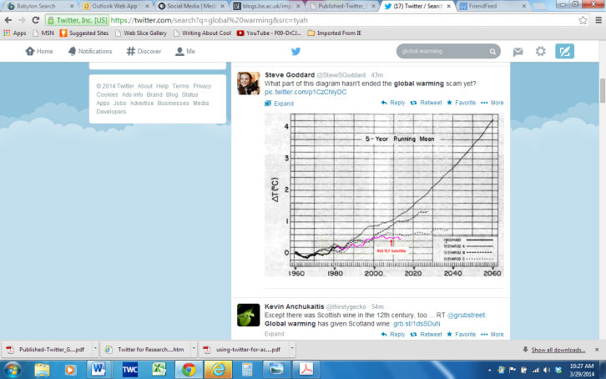
First, students find a post by Steve Goddard who displays a graphic showing, in his terms: “global warming [is a] scam.”


Students check his Twitter address and look at his history of Twitter posts. They notice he uses a picture of “Dorothy” from “The Wizard of Oz.” They notice he has 1,800+ followers, but only follows two Twitter authors.

Students investigate backwards to verify the media outlet, the author, and the article. They find on Yahoo Answers who Steven Goddard is and some of his blogging activities. They can see where his Twitter picture connects to his WordPress Blog’s theme. They identify his political agenda.

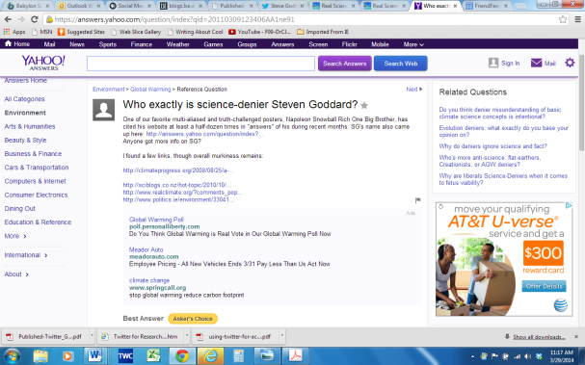



A contrasting article is found on global warming written by The Telegraph. Students compare the measured and scientifically supported article in The Telegraph to Stephen Goddard’s blog postings. They discuss the ethos of both sources and determine which source to include in their research as supporting arguments.


